

Specialized Retirement Plans

Author: Ryan Keats

Overview

This project will analyse life expectancy data and the correlation with specific variables to provide valuable insights for financial planners. By examining the different correlations that impact life expectancy, this analysis offers personalised retirement planning recommendations. The objective is to enhance clients' retirement plans, enabling well-informed decisions to safeguard their financial future, considering life expectancy projections.

Business Problem

A financial institution has sought out my assistance in identifying the ideal retirement age for their clients by analysing life expectancy data.

Taking into consideration health, lifestyle, and financial factors. The goal is to provide tailored retirement plans that align with individual life expectancies, ensuring clients' financial security as they move into their retirement.

Data

The dataset I used for my final regression modelling is from Kaggle, sourced from the World Health Organization (WHO), and focuses on life expectancy. It includes Economic Indicators (GDP, population, income composition, schooling), Health Indicators (life expectancy, mortality rates, healthcare expenditure) and Demographic and General Information (country, year, status). This dataset enables comprehensive statistical analysis to understand the factors influencing life expectancy across different regions and time periods.

Method

This project utilises exploratory data analysis (EDA) along with linear regression modelling, correlation matrix’s, QQ plots, Histograms and scatter plots to provide financial institutions with valuable insights for their specialized retirement advice; by ensuring data exploration and verifying model assumptions.

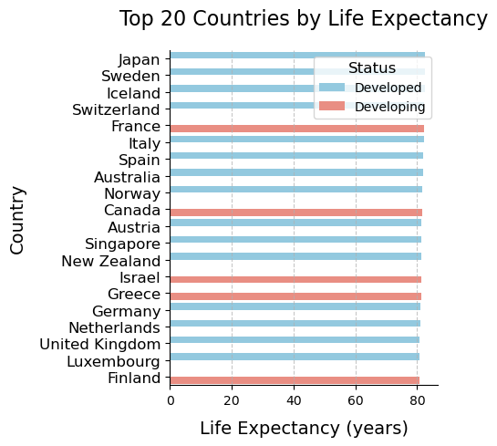

Results

The analysis of the linear regression models indicated good performances with the training and testing datasets. Trends emerged regarding the predictors' impact on life expectancy. Higher adult mortality showed a negative association, while increased infant deaths were linked to higher life expectancy. Alcohol consumption exhibited a negative correlation, whereas higher BMI had a positive effect. Presence of under-five deaths negatively affected life expectancy, while HIV/AIDS prevalence showed a significant negative impact.

On the other hand, higher income composition and schooling levels positively influenced life expectancy.

The intercept in the model indicated a baseline life expectancy of just under 51 years of age.

Another interesting outcome of the analysis is that in the top countries’ life expectancy developing nations still had some of the higher life expectancies.

An R-Squared of 0.85 is showing that over 85% of the predictors are explaining life expectancies, to obtain an even higher percentage further variables can be explored.

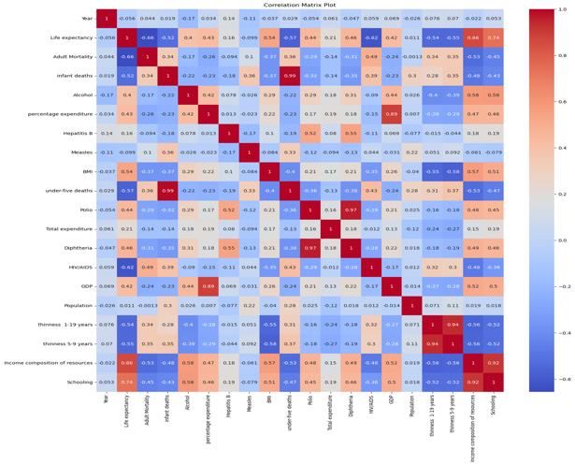

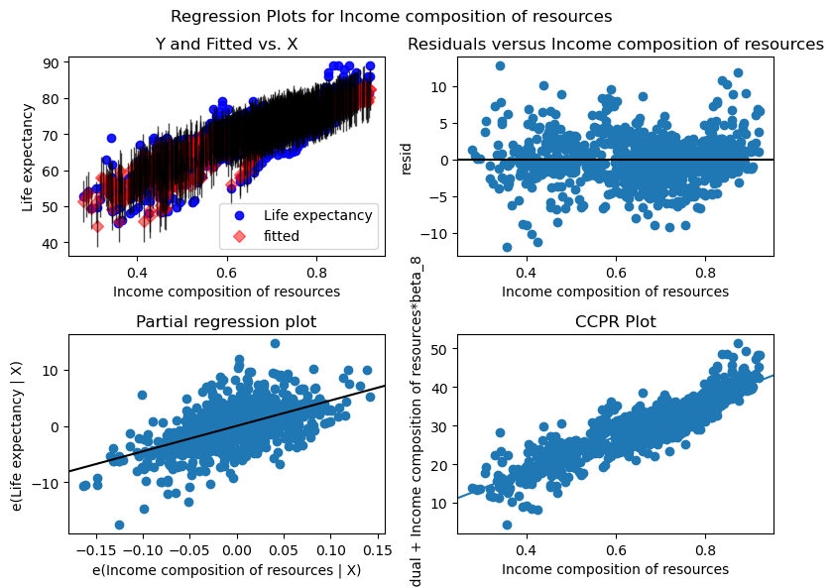

Conclusions

This analysis revealed what predictors showed impact on life expectancy. Higher adult mortality and alcohol consumption were associated with reduced life expectancy, while increased infant deaths and higher income composition positively influenced life expectancy. The findings underscore the importance of healthcare interventions and socio-economic factors in shaping life expectancy outcomes.

Next Steps

In the future, if you wanted to get a more precise outcome of life expectancy predictions,

I recommend further analysis into people’s activity and exercise, nutrition, sleep and work environments just to name a few would be great predictors to use against Life expectancy.

For more Information

Please review full analysis in [Jupyter Notebook](https://github.com/RyanKeats88/Capstone.git) or review this presentation.

For any additional questions, please contact Ryan Keats at [ryankeats16@gmail.com](mailto:ryankeats16@gmail.com)

Repository Structure

```

‚ data

, images

‚ README.md (RyanKeats88Capstone)

‚ Capstone [Capstone Notebook.ipynb](https://github.com/RyanKeats88/Capstone/blob/main/Capstone%20Notebook.ipynb) data

‚ RyanKeatsCapstonePresentation.pdf

